ftSQL stands for Structured Query Language.

# SELECT:

It is used to retrieve data from database.

SELECT name

FROM students;

# FROM:

It is used to mention the table from where we want to get the columns will all rows.

SELECT age

FROM students;

# TOP (5):

Top is used to limit the first rows till how much we want to retrieve data from rows. The parameter 5 means that we need top 5 rows from the column mentioned.

SELECT TOP (5) name

FROM students;

# PERCENT:

If we mention the percent keyword after top so instead of 5 rows, it’ll return 5% rows from top.

SELECT TOP (10) PERCENT name

FROM students;

# SELECT *:

Using * with select means that return all columns and rows from the required table.

SELECT *

FROM students;

# AS:

It’s used for aliasing. Used to give the selected column a temporary alias (alternative name) for the output. The alias doesn’t change the column name in the database it’s just for readability in the result.

SELECT name AS student_name

FROM students;

# DISTINCT:

The DISTINCT keyword is applied after SELECT. It filters out duplicate rows based on the columns listed in the SELECT statement.

SELECT DISTINCT age

FROM students;

# Order By:

Queries return set of data. And its not necessary that the data which we’ll get will be in the same sequence always. That’s why we use ORDER keyword to get the data in a specific order always.

The given below code will order in ascending. You want in descending then you can add DESC keyword after column name

SELECT TOP(10) PERCENT name

FROM students

Order By name, id

Specifying multiple columns in an ORDER BY clause allows you to define a more detailed sorting order. The database will sort the results **first** by the first column, and then **within rows that have the same value for the first column**, it will sort by the second column.

SELECT TOP(10) PERCENT name

FROM students

Order By name DESC, id

This ordering can be applied to columns having text as well.

# Defining criteria

We can define criteria with some conditions as well to get data from database.

Select name

From students

Where age > 15;

Or Where date = ’12-2-2023’

# <>:

In sql <> means those values those are either bigger or smaller than mentioned number and not equal to.

Where total BETWEEN 10 AND 30:

In this query between and “and” are used collectively to select data between a specific range.

If we want to exclude that range from our required data than we can use

Where total NOT BETWEEN 10 AND 30

# Selecting and excluding NULL values:

For selecting those values from column where the value is null we can use this code

Select name

From students

Where name IS NULL;

# And if we want to exclude null data then:

Select name

From students

Where name IS NOT NULL;

# Several Condtions:

We can apply several conditions using AND between condtions.

Select name

From students

Where age > 15

AND gender = ‘Male’;

# We can also use OR between them.

Select name

From students

Where age > 15

OR gender = ‘Male’;

# IN:

The IN keyword in SQL is used to filter records where a column's value matches any value in a specified list. It acts as a shorthand for multiple OR conditions.

SELECT * FROM employees

WHERE department IN ('HR', 'Finance', 'IT');

Returns all employees who work in the HR, Finance, or IT departments.

# LIKE:

The LIKE keyword in SQL is used in a WHERE clause to search for a specified pattern in a column. It is commonly used with wildcard characters:

**Wildcards**:

* %: Represents zero, one, or multiple characters.
* _: Represents a single character.

SELECT * FROM employees

WHERE name LIKE 'J%';

Returns all employees whose names start with "J".

SELECT * FROM employees

# WHERE name LIKE 'A_n';

Returns all employees whose names have "A" as the first letter, followed by any one character, and end with "n" (e.g., "Ann").

# SELECT * FROM employees

WHERE name LIKE '%son%';

Returns all employees whose names contain "son" anywhere.

# Aggregations in SQL

# SUM:

The SUM function in SQL calculates the total (sum) of a numeric column. It is often used to perform aggregations in combination with GROUP BY or on its own.

SELECT SUM(salary) AS total_salary

FROM employees;

This query calculates the total salary of all employees.

But if we want to sum several columns so its necessary to add several sum keywords otherwise we’ll get an error. And it necessary to add AS and a temporary name because when the sum is returned there will be no column name with it.

# COUNT:

The COUNT function in SQL is used to count the number of rows in a table or the number of non-NULL values in a column.

SELECT COUNT(*) AS total_rows

FROM employees;

This query counts the total number of rows in the employees table, including rows with NULL values.

SELECT COUNT(salary) AS total_salaries

FROM employees;

This query counts the number of non-NULL values in the salary column.

If we want to get unique values in result then:

SELECT COUNT(DISTINCT department) AS unique_departments

FROM employees;

This query counts the number of unique departments in the department column.

# MIN or MAX:

The MIN function in SQL is used to return the smallest (minimum) value in a column. It is commonly used to find the lowest value in a dataset, such as the lowest salary or earliest date.

SELECT MIN(salary) AS minimum_salary

FROM employees;

# AVG Function in SQL

The AVG function in SQL calculates the average (mean) of a numeric column. It is useful for finding average values, such as average salaries, prices, or scores in a dataset.

SELECT AVG(salary) AS average_salary

FROM employees;

This query calculates the average salary of all employees.

# LEN:

The LEN function in SQL is used to calculate the **length** of a string (the number of characters in a given text). It is often used to analyze text data, such as finding the length of names, codes, or other string-based columns.

SELECT LEN(name) AS name_length

FROM employees;

# LEFT and RIGHT Functions in SQL

The LEFT and RIGHT functions are used to extract a specified number of characters from the beginning or the end of a string, respectively. These functions are helpful in text manipulation, such as extracting prefixes, suffixes, or parts of a string.

SELECT LEFT(name, 3) AS first_three_characters

FROM employees;

# CHARINDEX:

The CHARINDEX function in SQL is used to find the starting position of a substring within a string. It is case-insensitive in most SQL implementations and is commonly used to locate specific characters or words in a text column.

SELECT CHARINDEX('SQL', 'Learn SQL with ease') AS position;

# SUBSTRING Function

The SUBSTRING function extracts a portion of a string, starting from a specified position and for a specified length.

SELECT SUBSTRING('Hello World', 7, 5) AS extracted_string;

(Extracts 5 characters starting from the 7th position.)

# REPLACE Function

The REPLACE function is used to replace all occurrences of a specified substring within a string with another substring.

SELECT REPLACE('Hello World', 'World', 'SQL') AS replaced_string;

(Replaces "World" with "SQL".)

# GROUP BY

The **GROUP BY** clause in SQL is used to group rows that have the same values in specified columns into aggregate data. It is often used with aggregate functions like SUM, COUNT, AVG, MIN, and MAX to perform operations on each group of rows.

SELECT department, COUNT(*) AS employee_count

FROM employees

GROUP BY department;

# HAVING Clause in SQL

The **HAVING** clause in SQL is used to filter groups of data that are created using the **GROUP BY** clause. It allows you to apply conditions to aggregated data (e.g., results of SUM, COUNT, AVG, etc.).

**Key Points**

1. **Used with GROUP BY**:
   * HAVING is applied to groups of rows after the aggregation.
   * Similar to the WHERE clause, but it works on aggregate data.
2. **Difference Between WHERE and HAVING**:
   * **WHERE**: Filters rows **before** grouping and aggregation.
   * **HAVING**: Filters groups **after** aggregation.

SELECT region, SUM(sales_amount) AS total_sales

FROM sales

GROUP BY region

HAVING SUM(sales_amount) > 3000;

# Primary Key

1. **Definition**: A column (or a set of columns) in a table that uniquely identifies each row in that table.
2. **Characteristics**:
   * **Unique**: The values in the primary key column(s) must be unique for each row.
   * **Non-Nullable**: It cannot contain NULL values.
   * **Single Table**: Each table can have only one primary key.
3. **Example**:

sql

Copy code

CREATE TABLE Students (

StudentID INT PRIMARY KEY, -- Primary Key

Name VARCHAR(50),

Age INT

);

Here, StudentID uniquely identifies each student.

# Foreign Key

1. **Definition**: A column (or a set of columns) in one table that refers to the **primary key** in another table, establishing a link between the two tables.
2. **Characteristics**:
   * Ensures **referential integrity** by enforcing that the value in the foreign key column matches a value in the referenced primary key column.
   * A table can have multiple foreign keys.
3. **Example**:

sql

Copy code

CREATE TABLE Enrollments (

EnrollmentID INT PRIMARY KEY,

StudentID INT,

CourseID INT,

FOREIGN KEY (StudentID) REFERENCES Students(StudentID)

);

* + Here, StudentID in Enrollments references StudentID in Students.
  + This ensures that every StudentID in Enrollments exists in the Students table.

# Getting data from two different tables:

SELECT

album_id, -- The unique identifier for each album.

title, -- The title of the album.

album.artist_id,-- The artist ID from the album table.

name AS artist_name -- The name of the artist, renamed as "artist_name" for clarity.

FROM album

INNER JOIN artist

SELECT *column_name(s)*  
FROM *table1*  
INNER JOIN *table2*ON *table1.column_name*=*table2.column_name*;

The SELECT clause specifies the columns to be retrieved from the tables:

* album_id, title, and artist_id come from the album table.
* name AS artist_name comes from the artist table, where name is renamed to artist_name for readability in the output.
* **FROM album**: Specifies the main table (album) to query.
* **INNER JOIN artist**: Combines the album table with the artist table based on a matching condition:
* This means rows from both tables are matched where the artist_id in the album table is equal to the artist_id in the artist table.
* Only rows that satisfy this condition are included in the result (because of the INNER JOIN).

# What is a LEFT JOIN?

SELECT *column_name(s)*  
FROM *table1*  
LEFT JOIN *table2*ON *table1.column_name*=*table2.column_name*;

* A **LEFT JOIN** returns **all rows from the left table** (in this case, the Admitted table), and the **matching rows from the right table** (Discharged table).
* If there is no match in the right table, the result will include NULL for the columns from the right table

# Comparison Between Inner Join and Left Join

* **Row Inclusion**:
  + **INNER JOIN** includes only matching rows from both tables.
  + **LEFT JOIN** includes all rows from the left table, with NULL for non-matching rows in the right table.
* **Non-Matching Rows**:
  + **INNER JOIN** excludes non-matching rows from both tables.
  + **LEFT JOIN** keeps non-matching rows from the left table.
* **Usage**:
  + **INNER JOIN** is used when you only need matching data between tables.
  + **LEFT JOIN** is used when you need all data from the left table, regardless of matches.
* **Result Size**:
  + **INNER JOIN** typically produces fewer rows.
  + **LEFT JOIN** may produce more rows if unmatched rows exist in the left table.

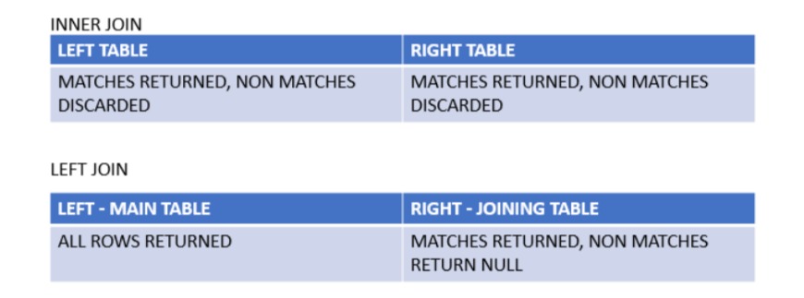

# UNION:

The **UNION** operator in SQL is used to combine the results of two or more SELECT queries into a single result set. It removes duplicate rows by default.

SELECT column1, column2

FROM table1

UNION

SELECT column1, column2

FROM table2;

# Union All:

The **UNION ALL** operator in SQL is similar to **UNION**, but it **does not remove duplicate rows**. It combines the results of two or more SELECT queries and includes **all rows**, even if some are duplicates.

CRUD Operations:

CRUD is combination of 4 words, create, read, update and delete.

# Create:

Create Table keyword is used to create a table. The table should have a unique name. for making columns, we have to define 3 things in parenthesis.

* 1. Column name
  2. Column data type
  3. Size (where necessary)

Create table test_table (

Test_date date,

Test name varchar (20),

Test_num int

)

# Data Types that can be stored in columns:

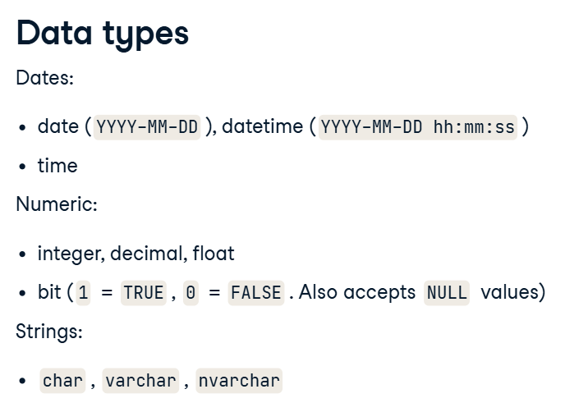

# INSERT INTO

The INSERT INTO statement is used to add new rows (records) into a table in a database. This is helpful when you want to add specific values manually or programmatically to a table.

**Syntax:**

INSERT INTO table_name (column1, column2, column3, ...)

VALUES (value1, value2, value3, ...);

# INSERT INTO ... SELECT

The INSERT INTO ... SELECT statement is used to copy data from one table to another. It allows you to select data from a source table and insert it into a target table, which is useful when migrating or transforming data.

**Syntax:**

INSERT INTO target_table (column1, column2, column3, ...)

SELECT column1, column2, column3, ...

FROM source_table

WHERE condition;

# Update:

The **UPDATE** statement in SQL is used to modify existing records in a table. This is helpful when you want to change specific values or multiple values in one or more rows based on certain conditions.

**Syntax**

UPDATE table_name

SET column1 = value1, column2 = value2, ...

WHERE condition;

# Delete:

The **DELETE** statement in SQL is used to remove one or more rows from a table. You can specify a condition to delete specific rows or omit the condition to delete all rows in the table (use this with caution!).

**Syntax**

DELETE FROM table_name

WHERE condition;

# Truncate:

The **TRUNCATE** statement in SQL is used to **remove all rows from a table** quickly and efficiently. Unlike the DELETE statement, TRUNCATE does not allow filtering with a WHERE clause—it always removes all rows.

**Syntax**

TRUNCATE TABLE table_name;

# DECLARE:

The DECLARE statement is used to **define variables** in SQL. These variables can hold temporary data, which can be used and manipulated during the execution of a script or procedure.

**Syntax**

DECLARE @variable_name datatype;

# SET:

The SET statement is used to **assign a value** to a variable declared with DECLARE.

**Syntax**

SET @variable_name = value;

Schema in Database:

Schema is Logical Representation of tables and data.